 | 26.2.2 Editors - Properties Editor - Render Properties Tab - EEVEE
Table of content
Detailed Table of content 1
Render Tab 4
Sampling panel 4
Clamping panel 5
Raytracing panel 5
Volumes panel 8
Curves panel 8
Simplify panel 9
Depth of Field panel 10
Motion Blur panel 11
Film panel 13
Performance panel 13

Detailed Table of content

Detailed table of content
Detailed Table of content 1
Render Tab 4
Sampling panel 4
Viewport subtab 4
Samples 4
Temporal Projection 4
Jittered Shadows 4
Render subtab 4
Samples 4
Shadows subtab 4
Rays 4
Steps 4
Volume Shadows 4
Steps 5
Resolution 5
Clamping panel 5
Surface subtab 5
Direct Light 5
Indirect Light 5
Volume subtab 5
Direct Light 5
Indirect Light 5
Raytracing panel 5
Use Ray-Tracing 5
Presets 6
Method 6
None 6
Screen-Trace 6
Resolution 6
Clamp 6
Screen tracing subpanel 6
Precision 6
Thickness 6
Denoising Subpanel 6
Denoising 6
Spatial Reuse 6
Temporal Accumulation 6
Bilateral Filter 6
Fast GI Approximation subpanel 7
Method 7
Global Illumination 7
Ambient occlusion 7
Resolution 7
Rays 7
Steps 7
Precision 7
Distance 7
Thickness near / far 7
Bias 8
Volumes panel 8
Resolution 8
Steps 8
Distribution 8
Max Depth 8
Custom Range subpanel 8
Start / End 8
Curves panel 8
Shape 8
Additional Subdiv 9
Simplify panel 9
Enable 9
Viewport subpanel 9
Max Subdivisions 9
Max Child Particles 9
Volume Resolution 9
Normals 9
Render 9
Max Subdivisions 9
Max Child Particles 10
Grease Pencil 10
Enable 10
Playback Only 10
Fill 10
Modifiers 10
Shader Effects 10
Layers Tinting 10
Antialiasing 10
Depth of Field panel 10
Max Size 10
Sprite Threshold 10
Neighbor Rejection 11
Jitter Camera 11
Overblur 11
Motion Blur panel 11
Enable 11
Position 11
Shutter 11
Bleeding Bias 11
Max Blur 11
Steps 11
Shutter Curve 11
Navigation elements 12
Zoom in and out 12
Use Clipping 12
Tools 12
Reset View 12
Extend Horizontal 12
Extend Extrapolated 12
Reset Curve 12
Handles 12
Vector Handle 12
Auto Handle 12
Auto Clamped Handle 12
X and Y values 13
Presets 13
Delete Points 13
Film panel 13
Filter Size 13
Animate Property 13
Overscan 13
Overscan Size 13
Performance panel 13
High Quality Normals 13
Memory Subpanel 13
Shadow Pool 13
Light Probes Volume Pool 14
Viewport Subpanel 14
Pixel Size 14
Compositor Subpanel 14
Device 14
Precision 14
Auto 14
Full 14

Render Tab

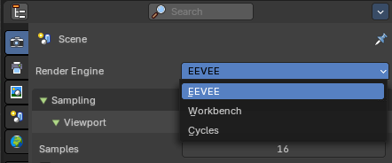
There are three different render engines available. Workbench, EEVEE, and Cycles. This chapter has a focus on the EEVEE render engine.

Sampling panel
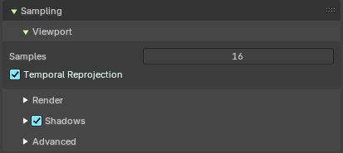

Viewport subtab

Samples
The number of samples when rendering in the viewport.

Temporal Projection
Denoise image using a method called temporal reprojection. This method can leave some ghosting.

Jittered Shadows
Enables jittered soft shadows in the viewport, improving shadow realism by introducing subtle randomness to shadow sampling. This helps reduce banding and aliasing artifacts in dynamic lighting setups.
Note: Jittered shadows are always enabled for final renders. This is an viewport override for performance.

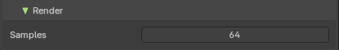
Render subtab

Samples
The number of samples when rendering to file.

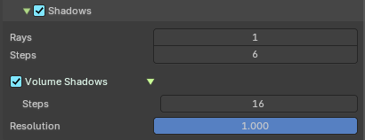
Shadows subtab

Rays
The number of samples when rendering to file.

Steps
Amount of shadow ray sample per shadow ray.

Volume Shadows
Generate shadows from volumetric material. This is very resources hungry.

Steps
Number of samples to compute volumetric shadowing.

Resolution
The resolution scale of the shadow map.

Clamping panel

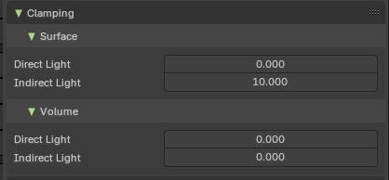
In this panel you can clamp the light values to minimum and maximum values.

Surface subtab

Direct Light
The maximum value for lights contribution on a surface. A value of zero disables this feature. Higher values will be scaled down to avoid too much noise and slow convergence at the cost of accuracy. Used by light objects.

Indirect Light
The maximum value for indirect lighting on a surface. A value of zero disables this feature. Higher values will be scaled down to avoid too much noise and slow convergence at the cost of accuracy. Used by ray-tracing and light-probes.

Volume subtab

Direct Light
The maximum value for lights contribution in volumes. A value of zero disables this feature. Higher values will be scaled down to avoid too much noise and slow convergence at the cost of accuracy. Used by light objects.

Indirect Light
The maximum value for indirect lighting in volumes. A value of zero disables this feature. Higher values will be scaled down to avoid too much noise and slow convergence at the cost of accuracy. Used by light-probes.

Raytracing panel

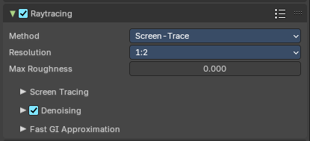

Use Ray-Tracing
Use ray-tracing.

Presets
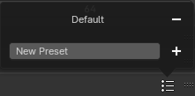
Allows you to store raytracing presets. To add a new preset type in a new preset name into the edit box at the end of the list, and click at the + sign.
To remove a preset click at the - sign behind the name.

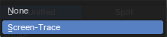
Method
Select the tracing method to find scene-ray intersections.

None
Do nothing.

Screen-Trace
Raytracing against the depth buffer.

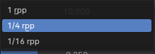
Resolution
The ray-tracing resolution. 1 Ray per pixel, 1 ray per 4 pixel, 1 ray per 16 pixel.

Clamp
Clamp ray intensity to reduce noise. Coose 0 to disable clamping.

Screen tracing subpanel
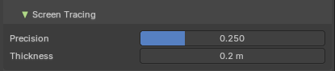
Just visible with the method Screen-Trace

Precision
Precision of screen space ray-tracing.

Thickness
Surface Thickness used to detect intersection when using screen-tracing.

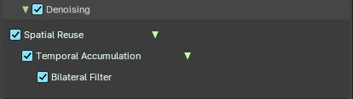
Denoising Subpanel

Denoising
Enable Denoising for raytraced effects.

Spatial Reuse
Reuse the rays of neighbour pixe.

Temporal Accumulation
Accumulate samples by reprojecting last tracing results

Bilateral Filter
Blur the resolved radiance by reprojecting last tracing result of the temporal accumulation.

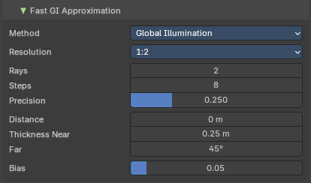
Fast GI Approximation subpanel

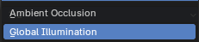
Method

Global Illumination
Computes global illumination. It takes light bounces off surrounding objects into account.

Ambient occlusion
Uses Ambient occlusion instead of Global Illumination. Ambient Occlusion is self shadowing, and doesn't calculate colors.

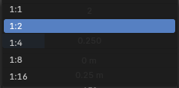
Resolution
The resolution of the AO or GI map. It is relative to the render resolution. 1 is the size of the full render resolution, 1/2 is half the size of render resolution, and so on.

Rays
Amount of GI or AO rays to trace for each pixel.

Steps
Amount of screen sample per GI or AO ray.

Precision
Precision of the Fast GI ray matching.

Distance
If non zero, the maximum distance at which other surfaces will contribute to the Fast GI approximation.

Thickness near / far
Geometric thickness of the surfaces when computing GI or AO. This feature reduces light leaking and missing contact occlusion.

Bias
Bias the shading normal to reduce self intersection artifacts.

Volumes panel

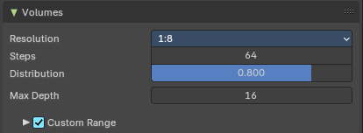
Contains volumetrics settings.

Resolution
The resolution of the Volumes map. It is relative to the render resolution. 1 is the size of the full render resolution, 1/2 is half the size of render resolution, and so on.

Steps
Number of samples to compute for the volumetrics effect.

Distribution
Distribute more samples closer to the camera.

Max Depth
Maximum surface intersection count used by the accurate volume intersection method. Thise feature will create artifacts if it is exceeded.

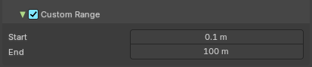
Custom Range subpanel
Enable custom start and end distances for volume computation.

Start / End
The start and end values for computation.

Curves panel

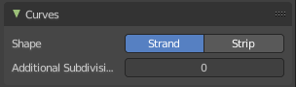
Shape
Choose if the hair is displayed as strand or as strip.

Additional Subdiv
Additional subdivision along the hair.

Simplify panel
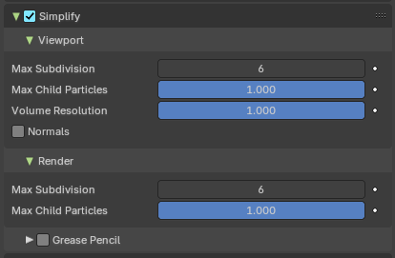
Sometimes you want to simplify the rendering without to loose the already tweaked settings and adjustments. For test renderings for example. Simplify allows you to simplify the rendering.

Enable
In the header is a checkbox to enable Simplify.

Viewport subpanel
This section affects the rendering with Eevee in the Viewport.

Max Subdivisions
Limit the number of maximum subdivisions.

Max Child Particles
Limit the number of child particles.

Volume Resolution
Simplify volumes by setting the resolution percentage of volume objects in viewport.

Normals
Skip computing custom normals and face corner normals for displaying meshes in the viewport.

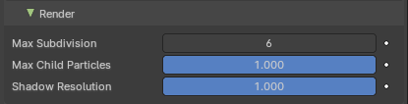
Render
This section affects the rendering with Eevee to file.

Max Subdivisions
Limit the number of maximum subdivisions.

Max Child Particles
Limit the number of child particles.

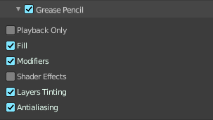
Grease Pencil
This section affects Grease Pencil drawings.

Enable
Enables the Grease Pencil features.

Playback Only
Simplify Grease Pencil only during animation playback.

Fill
Display Fill strokes in the Viewport.

Modifiers
Apply modifiers in the viewport.

Shader Effects
display shader effects.

Layers Tinting
Display layers tint.

Antialiasing
Use antialiasing to smooth stroke edges.

Depth of Field panel
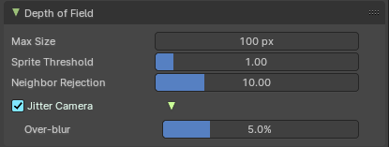

Max Size
The maximum size of the bokeh shape for Depth of Field. Lower is faster.

Sprite Threshold
Brightness threshold for using sprite base depth of field.

Neighbor Rejection
The maximum brightness to consider when rejecting bokeh sprites based on neighborhood. Lower is faster.

Jitter Camera
Jitter the camera to create accurate blurring by using render samples.

Overblur
Apply blur to each jittered sample to reduce undersampling artifacts.

Motion Blur panel
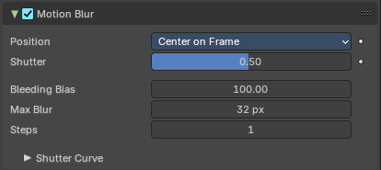
Enable Motion Blur and adjust the settings.
Each object has also its own settings to control motion blur. These options can be found in the corresponding Object tab of the Properties editor.

Enable
In the header is a checkbox to enable Simplify.

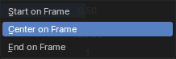
Position
Controls at what point the shutter opens in relation to the frame.

Shutter
Time taken in frames between shutter open and close.

Bleeding Bias
Reduce background bleeding onto foreground elements. Lower values = less bleeding.

Max Blur
The maximum blur distance that a pixel can spread over.

Steps
Controls the accuracy of motion blur. More steps means longer render time.

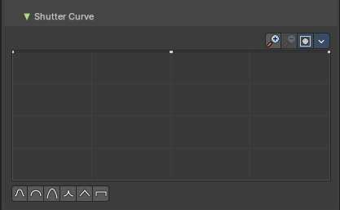
Shutter Curve
Sutter curve is a sub menu wAdjust a curve for the shutter effect.

Navigation elements
The navigation elements at the top are described from left to right.

Zoom in and out
The two buttons with the magnifying glass at it zooms in and out in the curve window.


Use Clipping
Clipping options. Set up clipping for the stroke.

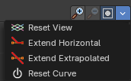
Tools
Tools is a menu that contains some curve related tools.

Reset View
Resets the curve windows zoom.

Extend Horizontal
Causes the curve to stay horizontal before the first point and after the last point.

Extend Extrapolated
Causes the curve to extrapolate before the first point and after the last point, based on the shape of the curve.

Reset Curve
Resets the curve to the initial shape.

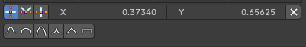
Handles

Vector Handle
Set handle type to Vector.

Auto Handle
Set handle type to Auto.

Auto Clamped Handle
Set handle type to Auto Clamped.

X and Y values
The coordinates of the currently selected curve point.

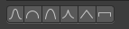
Presets
Curve presets.

Delete Points
Deletes selected curve points.

Film panel
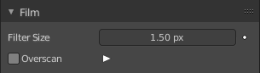

Filter Size
The width over which the reconstruction filter combines samples.

Animate Property
This property can be animated. Activating this button sets a keyframe.

Overscan
Internally render past the image borders to avoid screen space effects disappearing.

Overscan Size
How much bigger the image should be internally rendered.

Performance panel
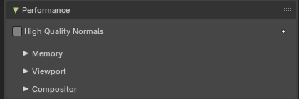

High Quality Normals
Use high quality tangent space. Slower but more accurate.

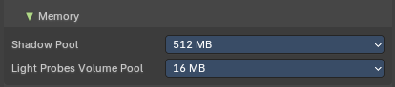
Memory Subpanel

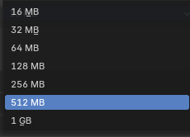
Shadow Pool
How much shadow data can be allocated for the scene. More ram usage means more possible shadows. This affects the GPU ram usage.

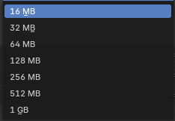
Light Probes Volume Pool
How much Light probes Volume data can be allocated for the scene. More ram usage means more possible light probes volumes. This affects the GPU ram usage.

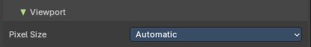
Viewport Subpanel

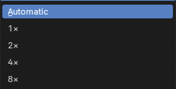
Pixel Size
The pixel size for viewport rendering.
Automatic depends of the user interface scale. 1 renders at full resolution. 8 renders just in 12.5% of the size.

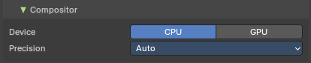
Compositor Subpanel
Realtime compositor settings.

Device
Which device to use for realtime compositing.

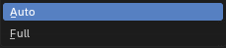
Precision

Auto
Full precision at rendering, half precision otherwise.

Full
Full precision in all cases.

